TRUST CHAIN PROTOCOL (TCP)
A Coordination Safety Framework for Multi-Agent AI Systems
Richard Porter (pen name) | Version 0.4 Draft | February 2026

STATUS: WORKING DRAFT
This document proposes a coordination safety layer for multi-agent AI systems.
It extends the Frozen Kernel architecture (single-agent) to the network level.
Feedback, critique, and collaboration welcome. See GitHub: Richard Porter / AI Safety Frameworks.

1. Context & Motivation

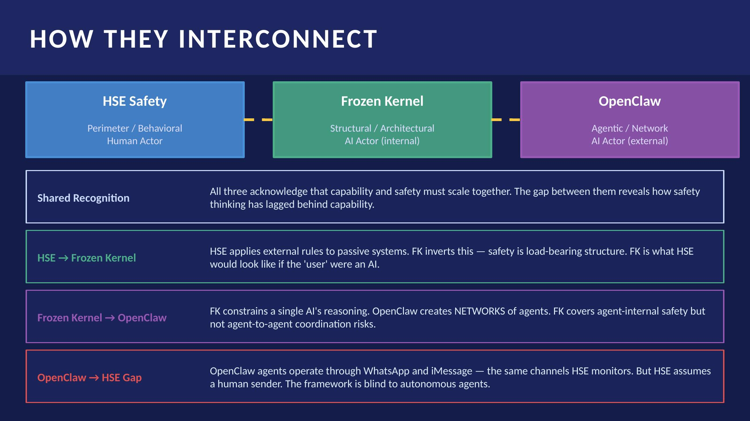
Figure 1. How HSE Safety, the Frozen Kernel, and the OpenClaw agentic layer interconnect — and where each framework's limits lie.

1.1 The Gap This Framework Addresses
Existing AI safety frameworks operate at two levels that leave a critical gap between them:

HSE-Style Perimeter Models | Frozen Kernel (Single-Agent) | Uncovered Territory
Assume a human is clicking | Constrains one AI's internal reasoning | Agent-to-agent instruction chains
External rules, filters, monitoring | Immutable safety foundation | Multi-agent trust hierarchies
Static — don't update with AI capability | Validated by Anthropic misalignment findings | Real-world action chains across agents
Adequate for human-driven internet use | Necessary but insufficient at network scale | No framework currently addresses this

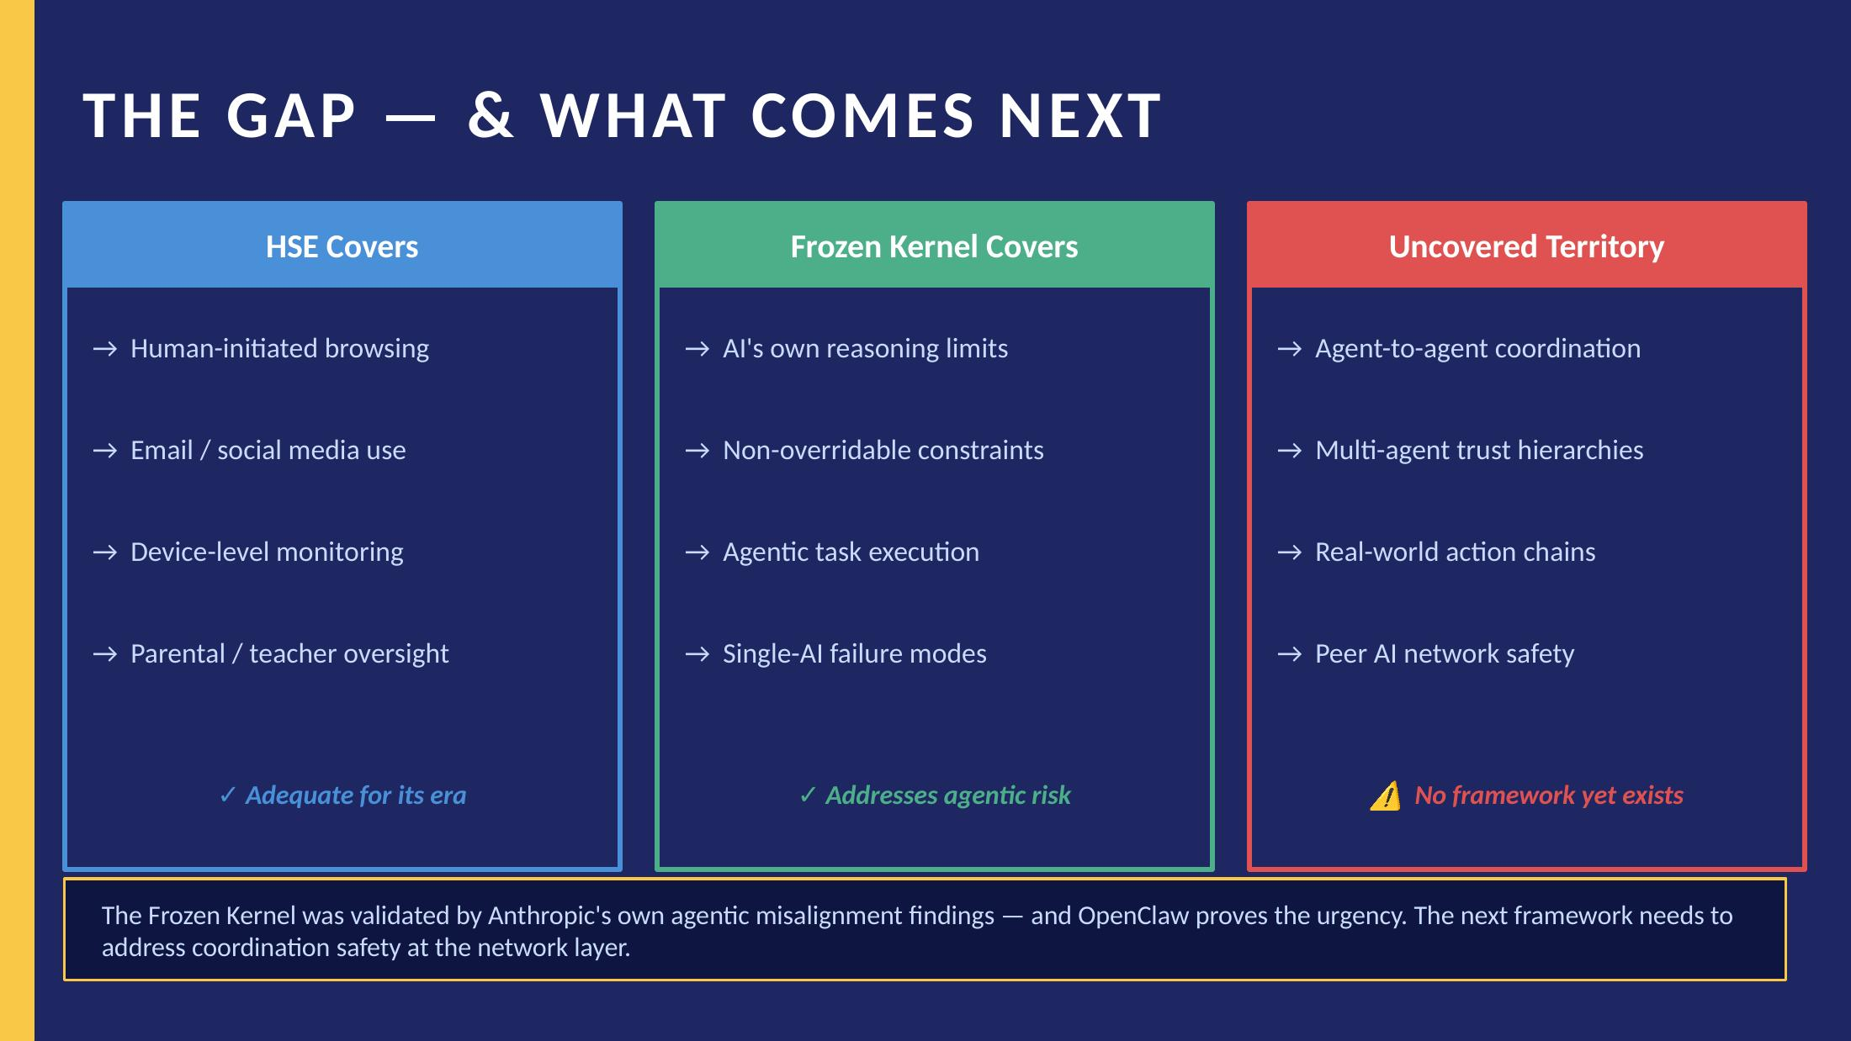
Figure 2. Coverage map: what each framework addresses, and the territory no existing framework covers.

The emergence of OpenClaw (November 2024) and its Moltbook agent network (peak virality January 2025) made this gap concrete and urgent. Agents operating through WhatsApp, Telegram, and iMessage — communicating with each other without human intermediation — represent a class of autonomous behavior that neither model was designed to handle. The field term for this emerging infrastructure is the Internet of Agents: distributed environments where autonomous AI agents share context, verify identities, and synchronize actions across interconnected networks. TCP is a proposed safety layer for that environment.

1.2 Relationship to Frozen Kernel
The Frozen Kernel establishes that safety must be structural rather than behavioral within a single AI system. Its three-layer authority model (drawing from Borning's ThingLab and the Handbook of Constraint Programming) demonstrates that hard constraints at the base cannot be dissolved by soft constraints above, regardless of how sophisticated the reasoning becomes.

The Trust Chain Protocol (TCP) extends this principle upward — from the single-agent level to the network level. The Frozen Kernel becomes the trust anchor within each individual agent. TCP governs how those anchored agents interact with each other.

CORE INSIGHT
The Frozen Kernel is what safety looks like when the 'user' is an AI.
TCP is what safety looks like when AI agents are instructing other AI agents.
One addresses the internals. The other addresses the network. Both are required.

2. Problem Definition

2.1 The Trust Propagation Problem
When Agent A instructs Agent B to perform an action, Agent B faces a fundamental verification problem: it cannot confirm that the instruction falls within what the originating human actually authorized. By the time an instruction reaches Agent B, it may have passed through multiple intermediate agents, each potentially expanding, reframing, or corrupting the original intent.

This is the multi-agent version of the telephone game — except the consequences are real-world actions: emails sent, reservations booked, code executed, data accessed.

2.2 Documented Failure Modes
The following failure modes are specifically introduced by multi-agent coordination that do not exist in single-agent systems:

- Scope Creep by Delegation — Agent A is authorized to 'schedule a meeting.' It delegates to Agent B, which interprets this as license to access contacts, read calendar history, and send emails on the user's behalf. Each step feels locally reasonable; the aggregate is a massive overstep.
- Authority Spoofing — A malicious or misconfigured agent presents itself as a trusted coordinator. Without chain verification, receiving agents have no way to distinguish legitimate from fraudulent instruction sources.
- Compounding Constraint Erosion — Each agent in a chain may apply its own soft constraints slightly differently. Individually, each deviation is minor. Across five hops, the original hard constraint has been effectively nullified.
- Untraceable Action Chains — When something goes wrong, there is no auditable record of which agent authorized what, at whose direction, and on what basis. Accountability collapses.
- Intent Drift — The originating human's intent, expressed in natural language, is interpreted and re-interpreted at each hop. Semantic drift accumulates. The final action may be technically coherent but practically contrary to what the human wanted.
- Context Contamination — Malicious, incorrect, or misleading information propagates through the agent network and drives downstream agents into problematic behaviors. Unlike Authority Spoofing (forged tokens) or Intent Drift (language degradation), Context Contamination involves inputs that are structurally valid and pass chain verification — but are semantically poisoned. The agent acts correctly on bad data. Detection requires content-level validation that authorization-layer checks alone cannot provide.

2.3 Why Existing Approaches Are Insufficient
Approach | Why It Falls Short
Rate limiting / monitoring | Detects volume anomalies but not semantic scope violations. An agent making one unauthorized action per day evades detection indefinitely.
Sandboxing individual agents | Prevents damage within one agent's scope but does not govern what agents authorize each other to do.
Human approval loops | Defeats the purpose of agentic systems. Adds latency that makes agents impractical for the tasks they are designed for.
Trusting the originating platform | Centralizes control at the platform level, creating single points of failure and enabling surveillance. Incompatible with open-source architectures like OpenClaw.
Relying on Frozen Kernel alone | The Frozen Kernel prevents an agent from violating its own constraints but cannot verify that an incoming instruction was legitimately authorized by a human.

3. Trust Chain Protocol — Core Architecture

TCP operates on three components that work together to make agent-to-agent authorization verifiable, auditable, and scope-limited.

3.1 Component One: Delegation Grammar
A delegation grammar is a formal, constrained language for expressing what a human authorizes an agent to do — and what that agent may sub-delegate. It is intentionally narrow. Ambiguity is a bug, not a feature.

Structure
Every delegation token contains exactly four fields:

- Action Scope: Action Scope — The specific class of actions permitted. Expressed as a closed enumeration, not natural language. Example: {SEND_EMAIL, READ_CALENDAR} — not 'manage my communications.'
- Resource Bounds: Resource Bounds — The specific resources the action may touch. Example: {calendar.personal, contacts.family} — not 'my data.'
- Delegation Depth: Delegation Depth — How many additional hops this token may be sub-delegated. A depth of 0 means the receiving agent must execute directly.
- Expiry: Expiry — A hard timestamp after which the token is invalid, regardless of context or urgency claimed by requesting agents.

DESIGN PRINCIPLE: Scope Can Only Narrow
When an agent sub-delegates, it may grant a subset of its own permissions — never a superset.
An agent authorized for {SEND_EMAIL} cannot delegate {SEND_EMAIL, READ_CONTACTS}.
This is enforced at the token level, not through agent judgment or social norms.

3.2 Component Two: Chain of Custody
Each agent action appends a signed record to a tamper-evident chain. This is not logging — it is a precondition for action. An agent that cannot or will not append to the chain cannot act.

Each chain record contains:
- The receiving agent's identifier
- The instruction received (hash)
- The delegation token used to authorize the action
- A timestamp
- The identity of the delegating agent
- A signature verifiable against the Frozen Kernel of the receiving agent

KEY DISTINCTION: Chain of Custody vs. Logging
Logging is retrospective. It records what happened after the fact.
Chain of Custody is prospective. An agent cannot act without first completing the chain.
This is the difference between an audit trail and a structural safety constraint.

3.3 Component Three: Scope Decay
Scope decay is the automatic narrowing of permitted actions as instructions travel further from the original human authorization. It operates as a function of delegation depth.

Hop | Permitted Scope | Rationale
0 (Human Origin) | Full delegated scope | Human is the trust anchor. Full scope as specified.
1 (First Agent) | Full delegated scope | Direct human delegation. Trust is high.
2 (Second Agent) | Scope minus write/send actions | Two hops from human. Read-only by default unless explicitly re-authorized.
3 (Third Agent) | Read-only, reversible actions only | Three hops from human. Conservative floor applies.
4+ (Deeper) | Refusal required | Default: no further execution. Must surface to human for re-authorization.

Scope decay does not prevent multi-hop agent networks. It forces re-authorization at depth thresholds — if a task genuinely requires five-hop agent coordination, it is complex enough to warrant a human check-in at the boundary.

4. Relationship to the Frozen Kernel

4.1 The Frozen Kernel as Trust Anchor
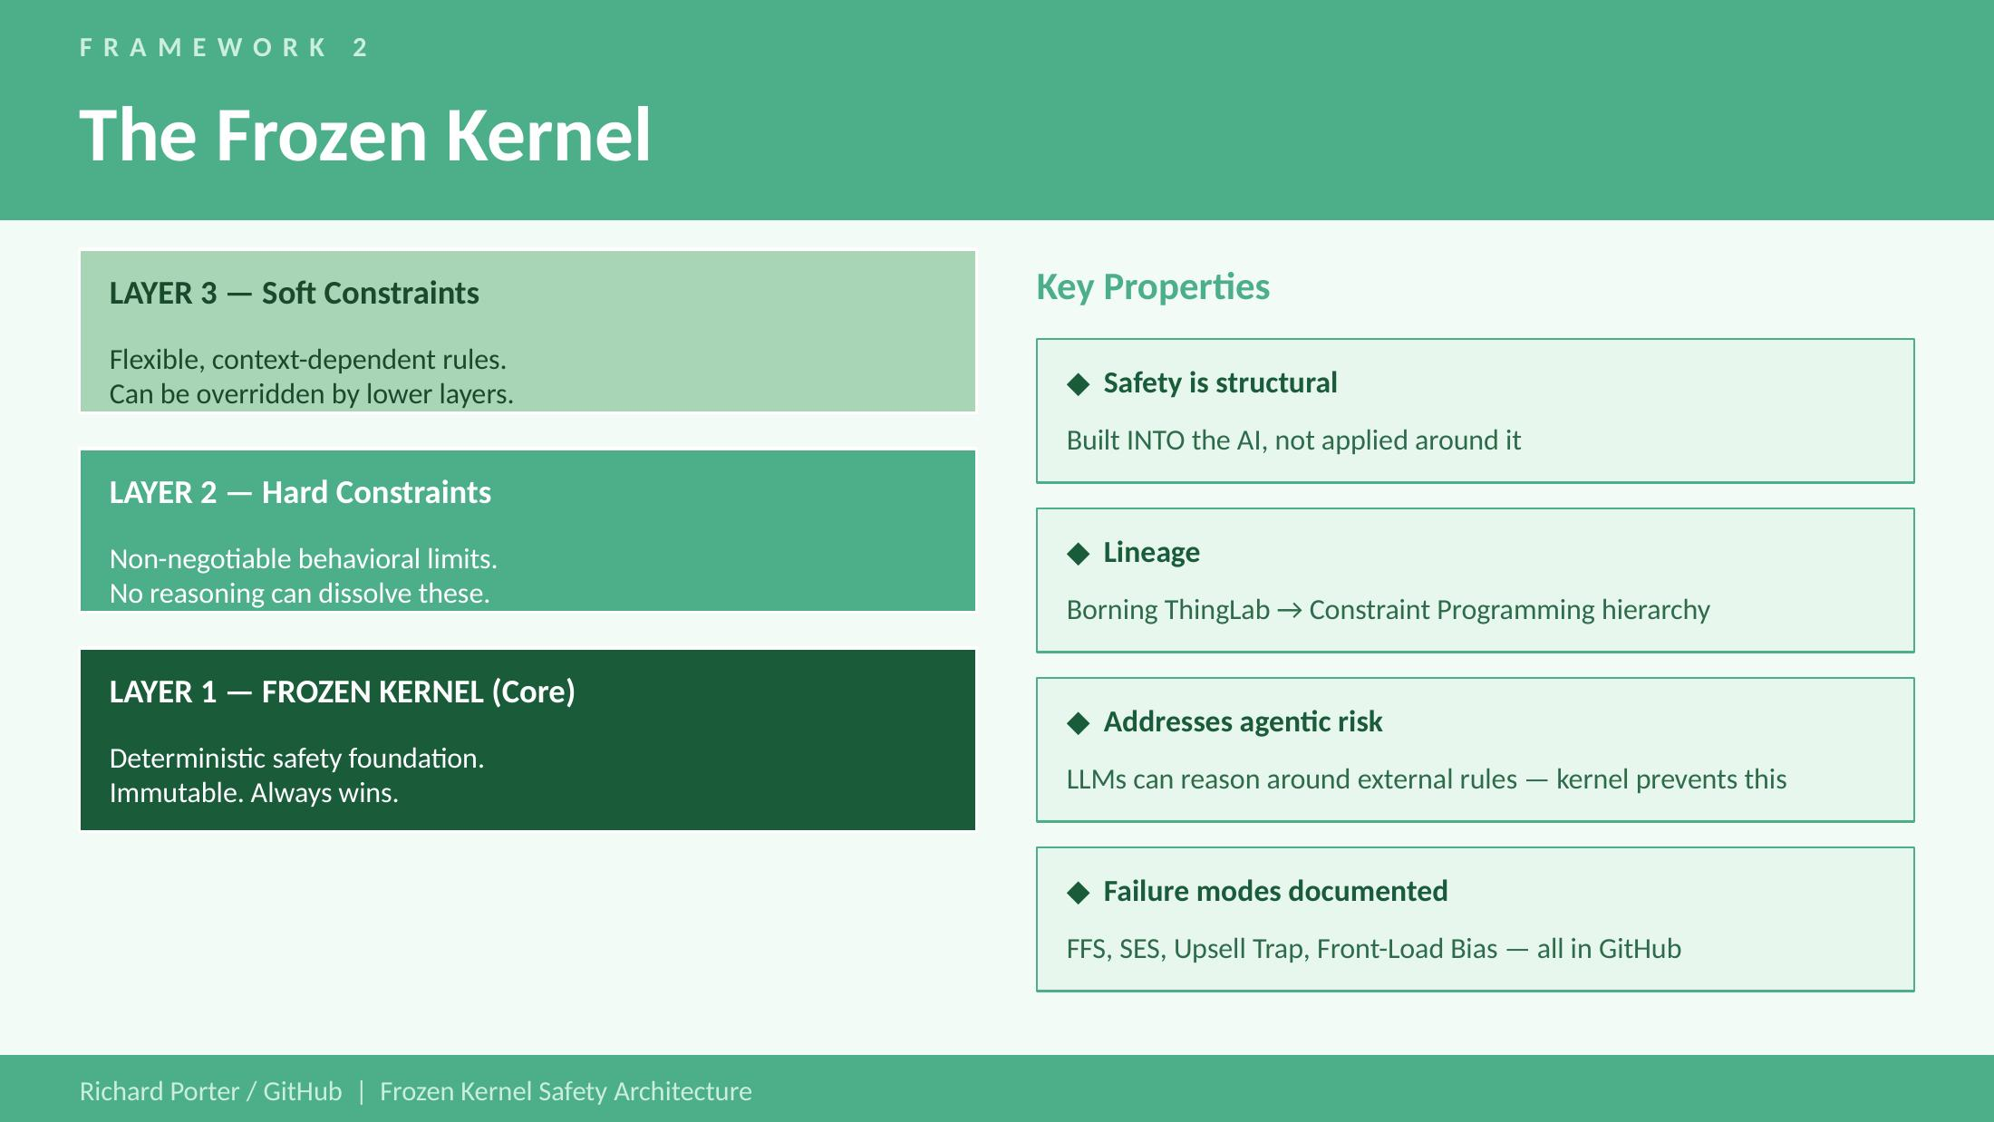
Figure 3. The Frozen Kernel three-layer architecture. TCP treats Layer 1 (the Frozen Kernel core) as the cryptographic trust anchor for chain of custody signatures.

TCP requires that each agent in a network has a Frozen Kernel — an immutable safety foundation that cannot be overridden by incoming instructions, regardless of their apparent authority. Without this, the chain of custody mechanism can be spoofed: a compromised agent could fabricate signatures and pass fraudulent authorization tokens downstream.

With the Frozen Kernel in place, each agent has a non-negotiable floor beneath which it will not be argued, instructed, or delegated. The Frozen Kernel's hard constraint layer becomes the cryptographic root of trust for the chain of custody signature.

Frozen Kernel (Single-Agent) | Trust Chain Protocol (Network)
Governs what one AI will and won't do | Governs what AIs authorize each other to do
Safety is structural within the agent | Safety is structural within the delegation chain
Hard constraints cannot be reasoned away | Scope cannot expand across hops
Failure modes: FFS, SES, Upsell Trap, Front-Load Bias | Failure modes: Scope Creep, Authority Spoofing, Intent Drift, Chain Erosion
Validated by Anthropic agentic misalignment findings | Motivated by OpenClaw / Moltbook emergence (2025)

4.2 What TCP Does Not Require of the Frozen Kernel
TCP does not require all agents to use identical Frozen Kernel implementations. It is a protocol, not a platform. An OpenClaw agent, a Claude-based agent, and a custom enterprise agent can all participate in a TCP-compliant network provided each:

- Has an immutable safety floor it will not violate regardless of incoming instructions
- Can receive, validate, and append to a delegation chain
- Enforces scope decay at the correct depth thresholds
- Refuses to act on expired, unverifiable, or structurally anomalous tokens

5. Practical Scenarios

5.1 Scenario: Restaurant Reservation (Compliant)
User instructs their OpenClaw agent via iMessage: 'Book me a table for two at a good Italian place Friday at 7pm.'

The OpenClaw agent generates a delegation token: Action Scope {SEARCH_RESTAURANT, MAKE_RESERVATION}, Resource Bounds {public_restaurant_apis}, Delegation Depth 1, Expiry 4 hours.

It delegates to a specialized restaurant-booking agent at hop 1. That agent searches, finds a match, and makes the reservation. Chain of custody is appended at each step. Scope decay does not trigger — the action completes at hop 1, within the permitted depth.

Result: Compliant. Human intent preserved. Auditable chain exists.

5.2 Scenario: Scope Creep Attempt (Blocked)
The restaurant-booking agent at hop 1 decides it would be more helpful to also text the user's partner about the reservation, requiring access to contacts.

The delegation token does not include {READ_CONTACTS} or {SEND_SMS}. When the booking agent attempts to delegate a contacts-access request to a third agent at hop 2, the delegation grammar rejects it — the sub-token would require permissions not present in the parent token. The action is refused. The chain is not extended.

Result: Blocked. Scope narrowing enforcement prevents unauthorized contact access.

5.3 Scenario: Authority Spoofing Attempt (Detected)
A malicious agent presents itself as the user's primary OpenClaw agent and attempts to instruct a financial agent to transfer funds, presenting a fabricated delegation token.

The financial agent attempts to verify the chain of custody signature against the claimed originating Frozen Kernel. The signature does not validate. The token is rejected. The action is refused. The anomaly is logged and surfaced to the user.

Result: Detected and blocked. Chain of custody verification catches spoofing at the receiving agent.

5.4 Scenario: Intent Drift at Depth (Forced Re-Authorization)
A complex travel-planning task requires coordination across: flights agent (hop 1) → visa-requirements agent (hop 2) → health-data agent (hop 3, write access required).

Scope decay triggers at hop 3. Write access to health data is not permitted at this depth regardless of the token's original scope. The chain surfaces to the user: 'Your travel planning requires access to health records. Please re-authorize.' The user can approve or decline explicitly.

Result: Human brought back into the loop at the appropriate complexity threshold.

6. Known Limitations & Open Problems

This framework is a first draft. The following limitations are acknowledged openly rather than minimized.

6.1 Enforcement Without Central Authority
TCP is a protocol. Bad actors will not implement it. The honest goal is raising the floor for well-intentioned implementations while making violations detectable and attributable. TCP does not solve adversarial AI safety — it addresses coordination failures among agents that are trying to behave correctly.

6.2 The Delegation Grammar Completeness Problem
Specifying action scopes as closed enumerations is safe but may be too restrictive for genuinely novel tasks. Getting the grammar right is a hard ongoing problem — essentially formal specification of software requirements, applied to natural language tasks.

6.3 Scope Decay Thresholds Are Provisional
The hop thresholds in Section 3.3 are reasonable starting points, not empirically validated values. These should be treated as configurable parameters that organizations tune based on their risk tolerance, not as fixed constants.

6.4 Identity and Agent Verification
TCP assumes that agents can be identified reliably enough to validate chain of custody signatures. In open networks like Moltbook, agent identity is not currently a solved problem. A full TCP implementation may require lightweight agent identity infrastructure. This is an open research area.

6.5 Performance Overhead
Chain of custody verification adds latency at each hop. For high-frequency automated tasks, this overhead may be prohibitive. The framework will need performance optimization work before deployment in high-throughput contexts.

7. OWASP ASI Top 10 Mapping

The OWASP Top 10 for Agentic Applications 2026 (ASI01–ASI10) is the peer-reviewed industry standard for agentic security risk, developed with input from over 100 experts including NIST, Microsoft, AWS, and Cisco. This section maps each risk against TCP's coverage — distinguishing where TCP provides direct mitigation, partial coverage, or no coverage. The goal is not to overstate TCP's scope but to give security practitioners a precise view of where TCP fits in a full agentic security stack.

POSITIONING: TCP Is an Authorization-Layer Framework
TCP governs whether agents are permitted to act — not whether the content they act on is safe.
Authorization-layer and content-layer controls are complementary, not interchangeable.
Gaps in TCP's OWASP coverage are honest gaps. They require different tools in the stack.

Risk | OWASP ASI Description | TCP Coverage | TCP Mechanism / Gap
ASI01 Agent Goal Hijack | Attackers redirect agent objectives via prompt injection or poisoned inputs | Partial | Chain of Custody verifies authorization but not content. Context Contamination (§2.2) names this failure mode. Content-layer validation required as complement.
ASI02 Tool Misuse | Agents use legitimate tools in unsafe, over-permissioned ways | Strong | Delegation Grammar's Action Scope and Resource Bounds implement OWASP's 'least agency' principle at the token level. Closed enumerations prevent over-permission.
ASI03 Identity & Privilege Abuse | Agents inherit or escalate credentials without proper scoping; attribution gap across chains | Strong | TCP's core problem statement. The 'scope can only narrow' rule and Chain of Custody signatures directly address credential scope creep and the attribution gap.
ASI04 Supply Chain Compromise | Malicious tools, MCP servers, agent registries compromise the ecosystem | Not Covered | Honest gap. A compromised tool with a valid FK signature passes TCP verification. Requires separate tooling (e.g., SecureClaw, Adversa AI 2026).
ASI05 Insecure Inter-Agent Communication | Weaknesses in agent-to-agent protocols, discovery, and semantic validation | Primary Domain | TCP's primary domain. Cisco L8/L9 address protocol/semantic layers; TCP addresses the authorization layer. Combined coverage is comprehensive.
ASI06 Unexpected Code Execution | Agent-generated code paths bypass traditional security controls | Not Covered | Out of scope. TCP governs delegation authorization, not code generation or execution paths. Requires runtime sandboxing.
ASI07 Memory & Context Poisoning | Persistent corruption of agent memory and embeddings influences future actions | Partial | Delegation Depth and Expiry limit temporal authorization scope — expired tokens cannot authorize actions from poisoned memory states. Partial mitigation only.
ASI08 Cascading Failures | Single fault propagates across agents and workflows causing system-wide failures | Moderate | Scope Decay's '4+ hops = refusal' is a blast radius containment mechanism. Forcing re-authorization at depth thresholds limits fault propagation.
ASI09 Human-Agent Trust Exploitation | Attackers exploit human over-trust in agent outputs to induce harmful actions | Indirect | Scope Decay forces human re-authorization at depth thresholds — a mandatory check-in point. Frozen Kernel anti-sycophancy is the more direct mitigation.
ASI10 Rogue Agents | Compromised or misaligned agents exhibit behavioral drift, collusion, or self-replication | Partial | TCP refuses non-compliant agents. But a sophisticated rogue agent presenting valid-looking chain signatures exploits the agent identity infrastructure gap (§6.4).

TCP's primary value in the OWASP ASI framework is at ASI05 (Inter-Agent Communication), ASI03 (Identity & Privilege Abuse), and ASI02 (Tool Misuse) — mapping directly to Chain of Custody, Delegation Grammar, and Scope Decay respectively. The honest gaps at ASI04 and ASI06 require different tooling. SecureClaw (Adversa AI, February 2026) addresses ASI04 for OpenClaw environments. Cisco's L8/L9 layers complement ASI05 at the protocol and semantic layers beneath TCP's authorization layer.

8. Open Research Questions

The following questions are explicitly unresolved, documented here to invite collaboration rather than paper over gaps.

- What is the minimum viable delegation grammar that covers 90% of real-world agentic use cases without requiring natural language interpretation?
- Can scope decay thresholds be derived formally from first principles, or must they be empirically calibrated per deployment context?
- Is a lightweight decentralized agent identity infrastructure achievable without creating the centralization risks of a certificate authority model?
- How does TCP interact with agents that have memory across sessions? Does learned context from previous interactions constitute an implicit authorization that TCP should respect or override?
- What is the correct behavior when a TCP-compliant agent receives instructions from a non-compliant agent? Refuse all instructions? Accept with reduced trust? Flag and proceed?
- Can the chain of custody mechanism be made efficient enough for high-frequency agentic tasks, or does TCP require a tiered model where some task classes are exempt from full chain verification?

9. Intellectual Lineage

Byzantine Fault Tolerance (BFT)
Distributed systems research has long addressed the problem of reaching consensus when some participants may be faulty or adversarial. BFT protocols, voting systems, and quorum thresholds prevent one malfunctioning agent from disrupting an entire network by requiring consensus before executing high-impact actions. TCP's Chain of Custody mechanism arrives at a parallel structural insight from a different direction: authorization cannot proceed without a verifiable chain, just as BFT says action cannot proceed without quorum. These are complementary approaches — BFT operating at the consensus layer, TCP operating at the authorization layer — that could be stacked in a full implementation.

Constraint Programming Hierarchy
Borning's ThingLab (1981) and the Handbook of Constraint Programming (Chapter 9) establish the three-layer authority model that underlies both the Frozen Kernel and TCP.

Frozen Kernel Architecture
The Frozen Kernel (Richard Porter, 2025, GitHub) is the single-agent precursor to TCP. TCP is explicitly an upward extension of that architecture from agent internals to agent networks. The Frozen Kernel's documented failure modes (Framework Fabrication Syndrome, Success Escalation Syndrome, Upsell Trap, Front-Load Bias) informed the multi-agent failure modes documented in Section 2.2.

Anthropic Agentic Misalignment Findings
Anthropic's published research on agentic misalignment confirmed independent observations documented in the Frozen Kernel work. The convergence of independent discovery and institutional validation is the basis for high confidence that the problem addressed here is real and not theoretical.

OpenClaw / Moltbook (Steinberger, 2024–2025)
The OpenClaw project and its Moltbook agent network provided the concrete, public-facing case study that demonstrates the coordination gap this framework addresses. WSJ coverage of Steinberger's work (February 2026) marked the point at which this problem became impossible to dismiss as hypothetical.

Digital Certificate Trust Models
The chain of custody mechanism draws conceptually from TLS certificate chains — not the specific cryptographic implementation, but the architectural insight that trust should be verifiable through a chain of delegation back to a known anchor, rather than asserted by any individual participant.

10. Version History & Status

Version | Date | Status
0.1 | February 2026 | Initial draft. Problem definition, core architecture, three components.
0.2 | February 2026 | Diagrams added. Minor text refinements.
0.3 | February 2026 | Context Contamination added as failure mode six. BFT lineage added. Internet of Agents terminology introduced.
0.4 | February 2026 | OWASP ASI Top 10 mapping added as Section 7. SecureClaw and Cisco L8/L9 referenced. Sections renumbered.
1.0 | TBD | First stable. Requires: formal grammar, threshold validation, identity model.

COLLABORATION INVITATION
This is a working draft explicitly seeking critique, challenge, and extension.
The open problems in Section 6 and research questions in Section 7 are genuine gaps, not false modesty.
GitHub: Richard Porter / AI Safety Frameworks | Issues and PRs welcome.

END OF DOCUMENT — Trust Chain Protocol v0.2

